EJERCICIO 3

--> f1=inline('log(x)-cos(x)')

f1 =

inline function object

f(x) = log(x)-cos(x)

--> x=0.5:0.2:5

--> y=f1(x)

--> plot(x,y)

--> grid on

--> hold on

--> raiz=fzero(f1,1.2)

raiz =

1.3030

--> plot([1.3030 1.3030],[-1 1],'g','LineWidht',3)

--> axis([0 5 -2 2.5])

--> xlabel('eje x')

--> ylabel('eje y')

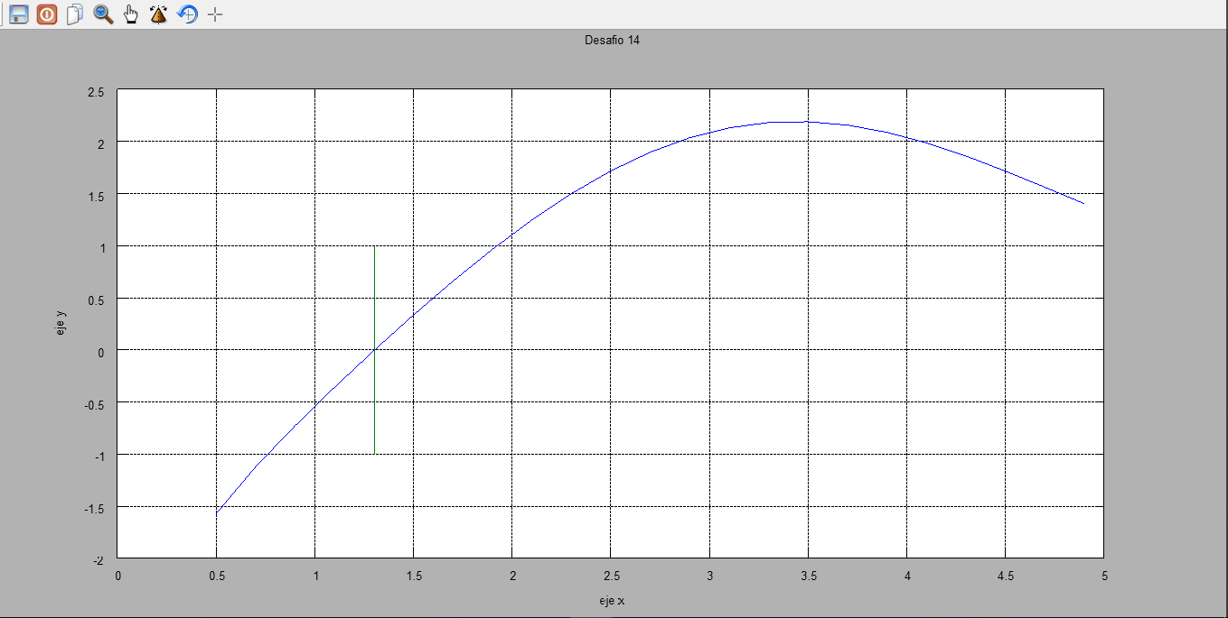--> title('Desafio 14')